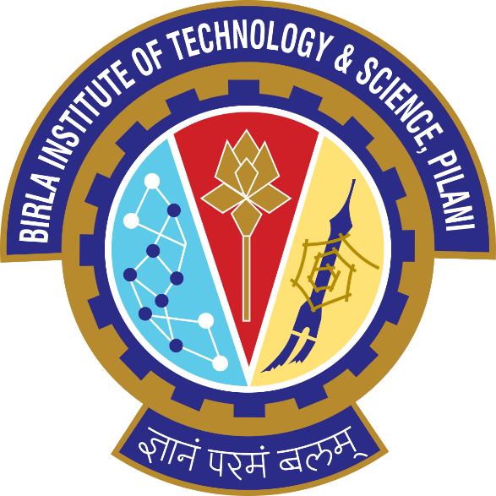

Birla Institute of Technology and Science, Pilani
(BITS Pilani)

Assignment report on:
“Operating System”
(Wipro ID : CH954245)

Submitted By:
“Chetan Singh Sengar”
“Bits ID. 2017HW86656”

